Project Design Phase-I

Problem Solution Fit :

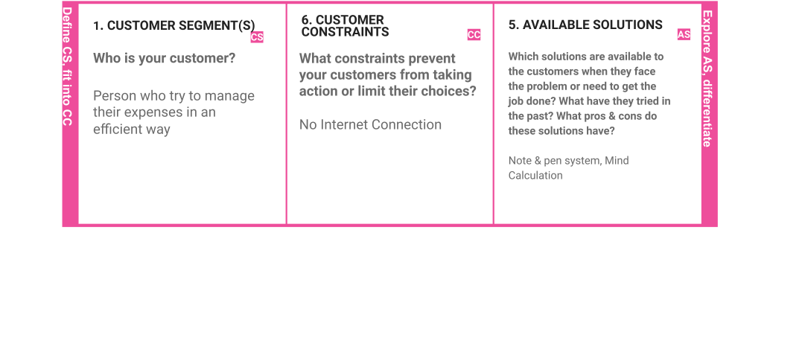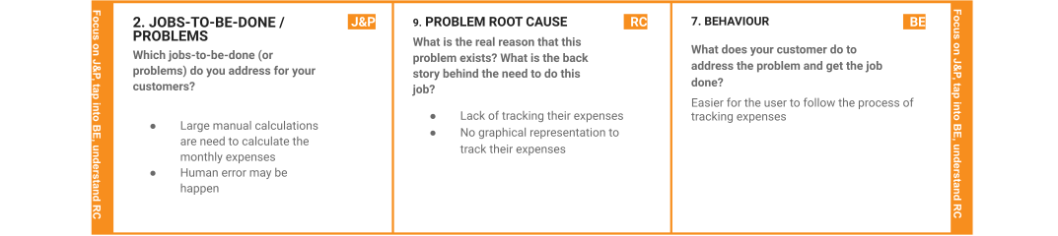

|  |  |  |  |  |  |
| --- | --- | --- | --- | --- | --- |
|  | **3. TRIGGERS** | **TR** | **10. YOUR SOLUTION SL** | 1. **CHANNELS of BEHAVIOUR CH**    1. **ONLINE**   **What kind of actions do customers take online?**   * + - Tracking their expenses     - Getting detailed reviews from email notiﬁcation   1. **OFFLINE**   **What kind of actions do customers take ofﬂine?**  Export the data when online and use it in oﬄine |  |
| **What triggers customers to act?** |  |  |
| It reduces time rather than writing it manually in the | |  |
| notebook |  | * Create a web application to track their expenses anywhere at any time * Get real-time graphical representation of their expenses * Alert notiﬁcation through email |
| **4. EMOTIONS: BEFORE / AFTER EM**  How do customers feel when they face a problem or a job and afterward? | |
| **Before:** Diﬃcult to track the expense and struggle to analyze their expenses after spending it | |  |
| **After:** Easy to track the expenses and graphical representation allow them to understand the expenses they made before easily | |  |

**Proposed Solution Template**

Project team shall fill the following information in proposed solution template.

|  |  |  |
| --- | --- | --- |
| **S.No.** | **Parameter** | **Description** |
| 1. | Problem Statement (Problem to be solved) | Earlier, our parents use to track all their expenses by writing down in a small notebook and calculating it on their own Even still many of them follow the same to maintain their financial expenses even some of them don’t care of their expenses and spendings.  Not only in our homes ,Expenses are need to be tracked in many large scale and small scale sectors such as in many schools, colleges, marketing companies , departmental stores , etc  So in order to optimize their work and make peoples life easier our expense tracker application will be much helpful for financial management  The outcome of the application will be much useful for them to acknowledge the daily expenses and track the monthly expenses from their income with a limit to spend. They can easily track and view their expenses with a statistical data.  In short, tracking our financial expenses is a great deal especially in this scenario so making those tracking easier is the job of this application. |

|  |  |  |
| --- | --- | --- |
| 2. | Idea / Solution description | Due to the busy and hectic lifestyle people tend to overlook their budget and end up spending an excessive amount of money since they  usually didn’t plan their budget wisely. user cannot predict future expenses. While they can write down their expenses in a excel spreadsheet, their lack of knowledge in  managing finances will be a problem |
| 3. | Novelty / Uniqueness | This application tracks your every expenses anywhere and anytime without using the paper work. Just click and enter your expenditure. to avoid data loss, quick settlements and reduce human error. To provide the pie chart or graph lines in this application. |
| 4. | Social Impact / Customer Satisfaction | Using this application one can track their personal expenses and frame a monthly/annual budget. If your expense exceeded than specified limit, the application will show you an  alert message in form of a pie chart. |
| 5. | Business Model (Revenue Model) | Business people can use subscription/premium feature of this application to gain revenue. |
| 6. | Scalability of the Solution | IBM cloud will automatically allocate the storage for the users. |

**SOLUTION ARCHITECTURE**

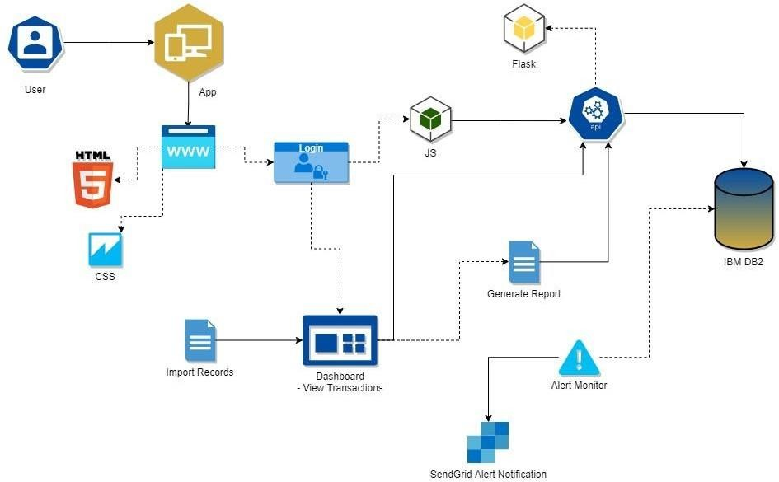

**User Expense Inputs**